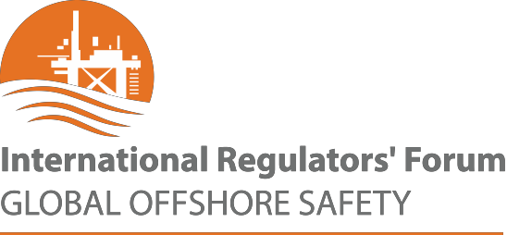

Communiqué

International Regulators’ Forum Holds 2023
Mid-Year Meeting
Focused on Offshore Petroleum Safety

July 17, 2023

The International Regulators’ Forum (IRF) held its Mid-Year Meeting (MYM) on 2 May 2023. This year’s forum was hosted by BSEE (USA member) in Houston, TX, USA and attended in person or virtually by offshore petroleum health and safety regulator leaders from most of its 11 member countries – Australia (Chair), Brazil, Canada, Denmark, Ireland, Mexico, the Netherlands, New Zealand, Norway, the United Kingdom, and the United States. NOPSEMA (Australia) incoming CEO Sue McCarrey was welcomed to the IRF and Chair of the MYM.

The MYM afforded IRF members the opportunity to share summary updates of matters that had arisen since the October 2022 Annual General Meeting. Representatives of global Industry Associations, the International Oil and Gas Producers (IOGP) and the International Association of Drilling Contractors (IADC) joined to discuss industry trends in safety. The preliminary IOGP data for 2022 showed a very concerning increase in global onshore and offshore fatalities in both 2021 and 2022. The largest increase was in contractor personnel. Lost-time-injuries (LTIs) also showed a considerable increase in 2022.

The IOGP data was seen by the IRF members as a warning sign that industry risks had climbed since 2020 (ie. during and post-Covid). Irrespective the reasons for this apparent worsening trend in safety performance, the IRF members agreed to highlight their concern in this Communique with a view to alerting personnel at all levels in industry to these risks and seek to reinforce the application of appropriate prevention controls. IRF members called upon industry leaders in their vital role of exercising executive oversight and accountability to ensure worker safety.

Australia is in the role of IRF Chair until the end of 2024 and will host the next IRF Conference Perth, Australia on 3 & 4 October 2023. The conference brings together the 11 IRF offshore petroleum regulators to discuss mutual challenges and opportunities and drive continuous improvement in safety outcomes. The conference program is being finalised and will include plenaries as well as smaller sessions featuring a wide variety of international thought leaders, key industry and regulatory figures from both inside and outside of the IRF membership. Don't miss out on attending this important international event! Subscribe here to be notified when registrations open.

Contact:
Derrick O’Keeffe
derrick.o'keeffe@nopsema.gov.au

